**CLOUD COMPUTING LAB**



**SUBMITTED TO**  
SIR WAQAS SALEEM  
  
**SUBMITTED BY**  
HAMNA MAHMOOD  
2023-BSE-025

BSE V-A

**LAB 03**

**Working with Git History, Stashing, and Reverting Commits**

**Repository Link:** https://github.com/HamnaMahmood20/CC-Hamna-Mahmood-25-BSE-VA

**Task 1**

**Handling Local and Remote Commit Conflicts (Pull vs Pull --rebase)**

**Save a screenshot of your terminal as local_commit.png.**

First making a new repository of Lab 3,

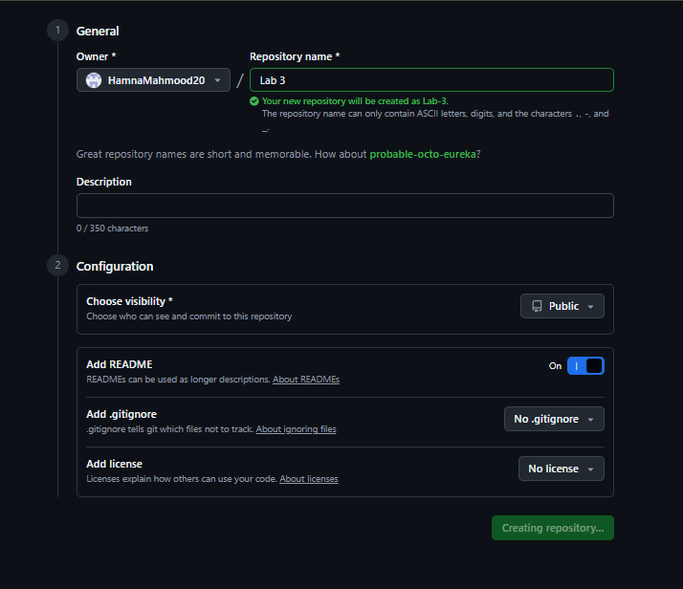

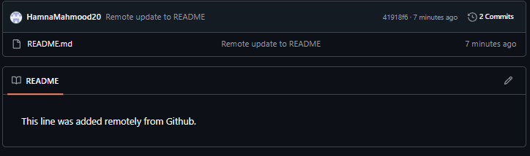

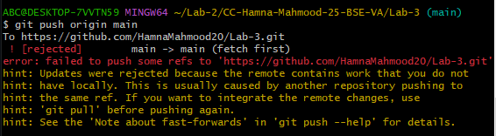

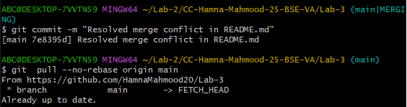

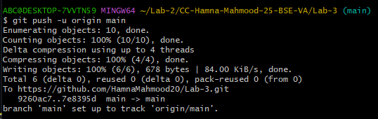

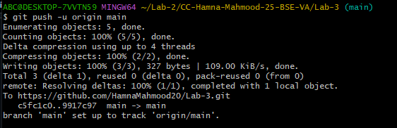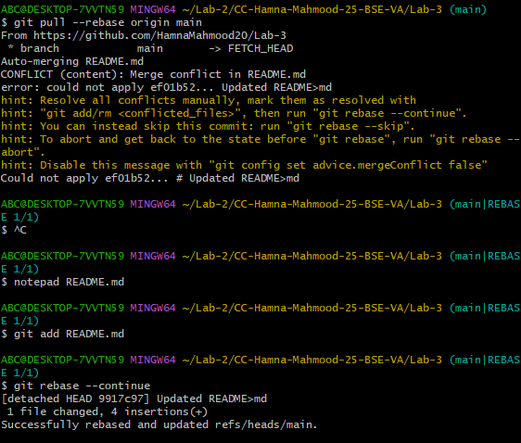

**Task 2**

**Creating and Resolving Merge Conflicts Manually**

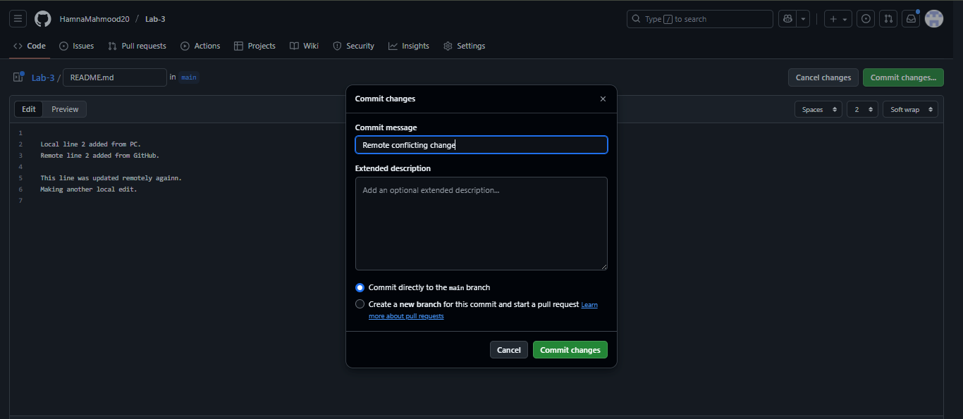

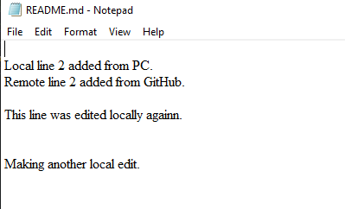

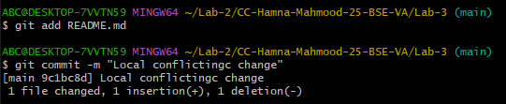

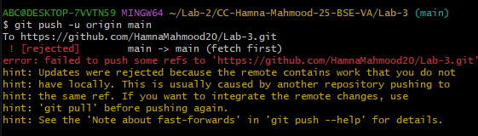

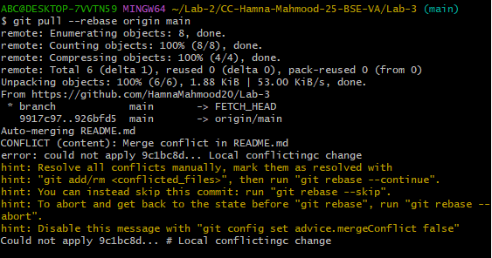

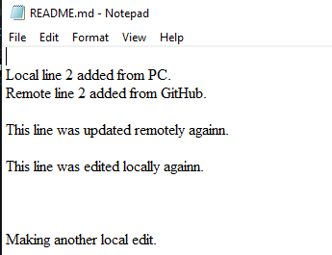

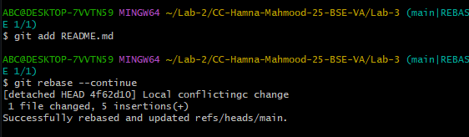

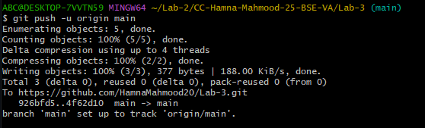

**Task 3**

**Managing Ignored Files with .gitignore and Removing Tracked Files**

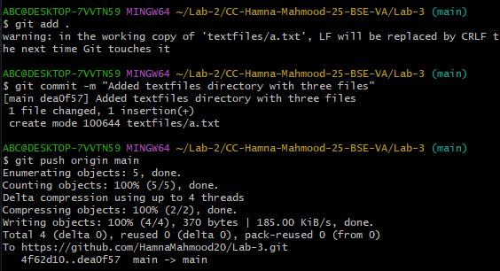

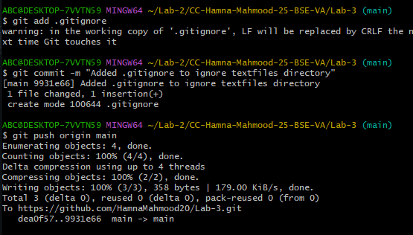

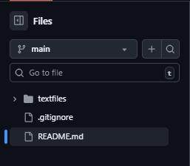

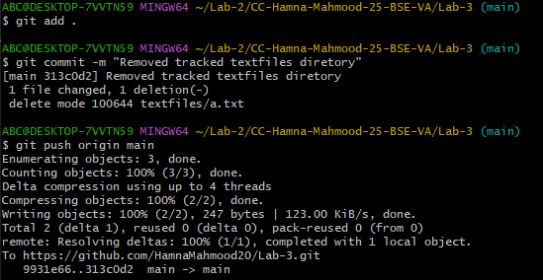

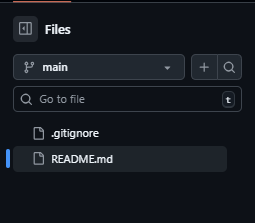

**Task 4**

**Create Temporary Changes and Use git stash**

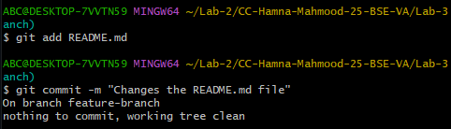



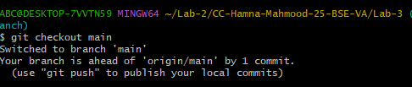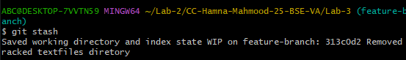

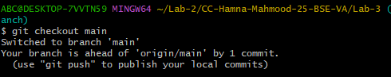

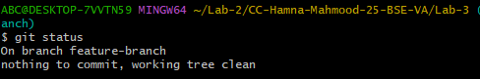

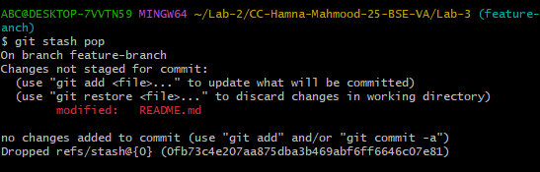

**Task 5**

**Checkout a Specific Commit Using git log**

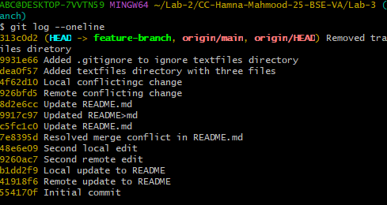

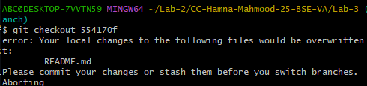

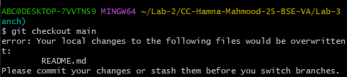

**Task 6**

**Resetting Commits (Soft vs Hard Reset) (With Verification Steps)**

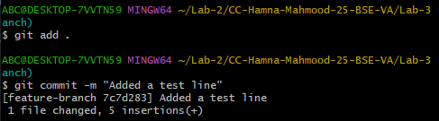

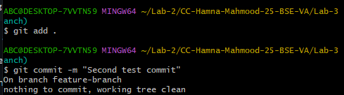

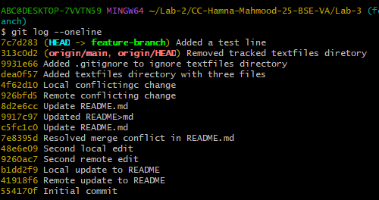

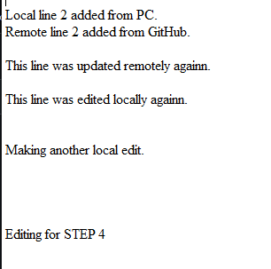

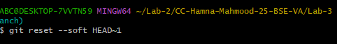

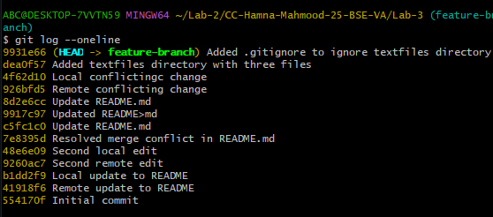

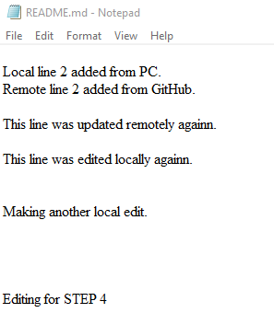

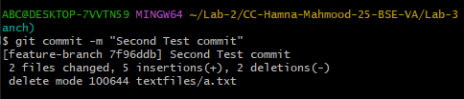

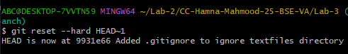

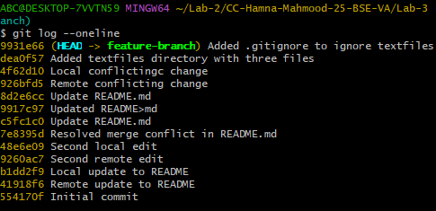

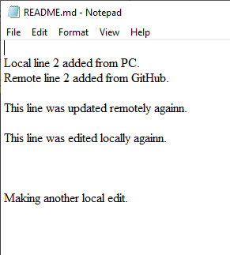

**Task 7**

**Amending the Last Commit**

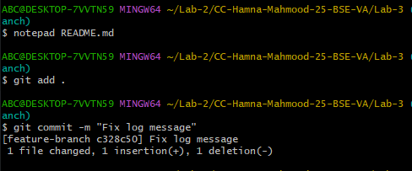

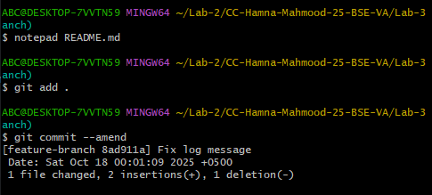

**Task 8**

**Reverting a Commit (Safe Undo on Remote Branch)**

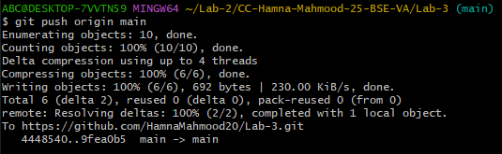

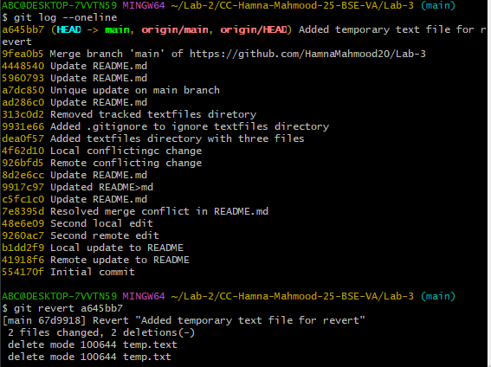

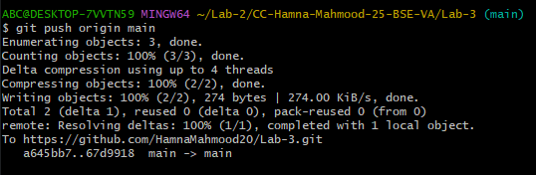

**Task 9**

**Force Push (With Caution)**



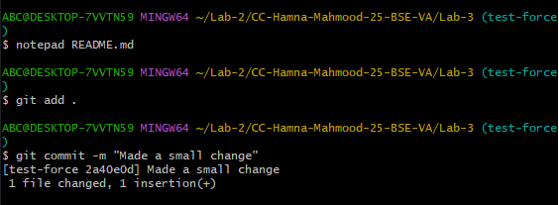

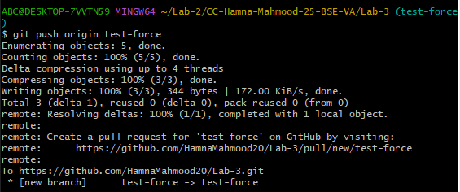

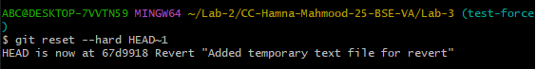

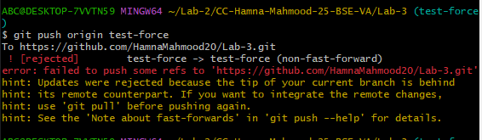

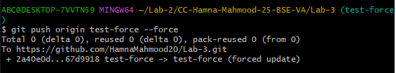

**Task 10**

**Running Gitea in GitHub Codespaces via Docker Compose**

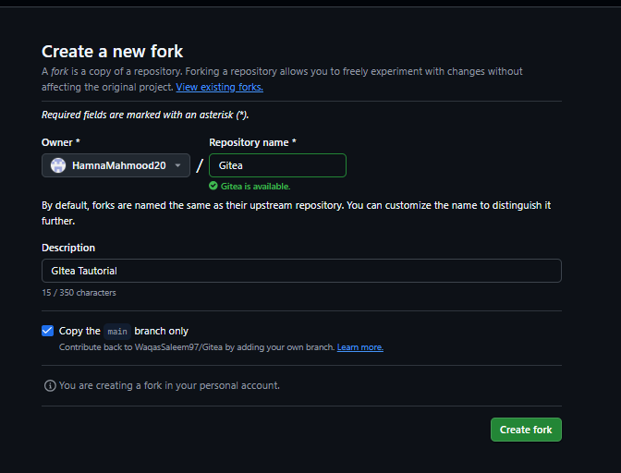

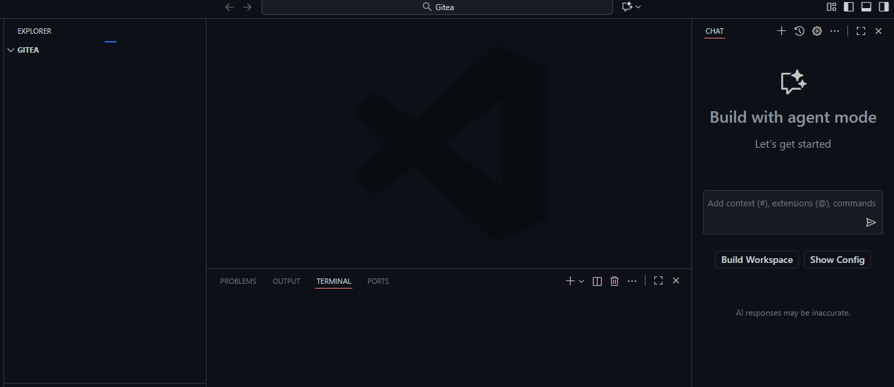

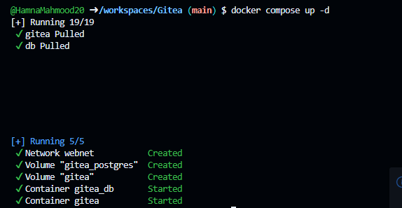

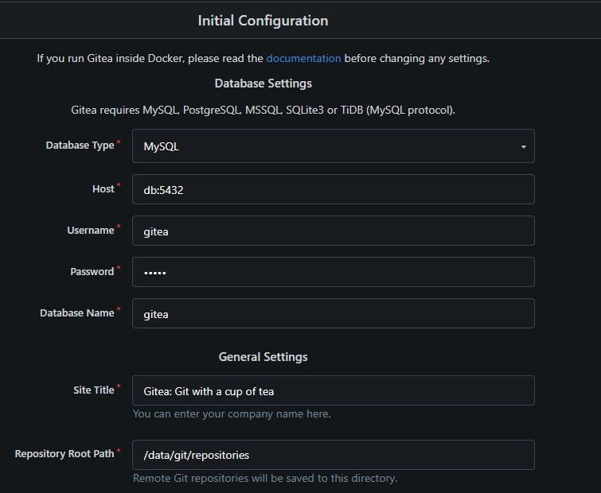

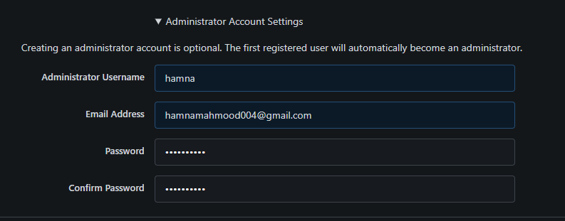

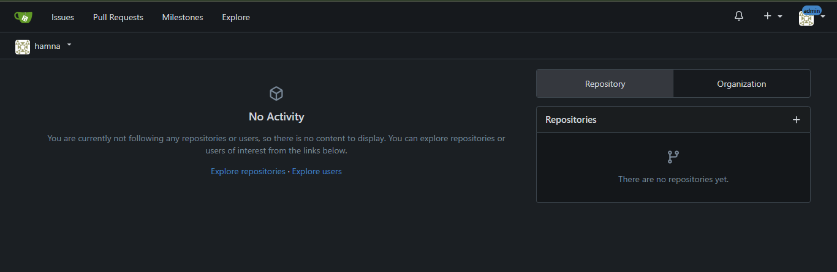

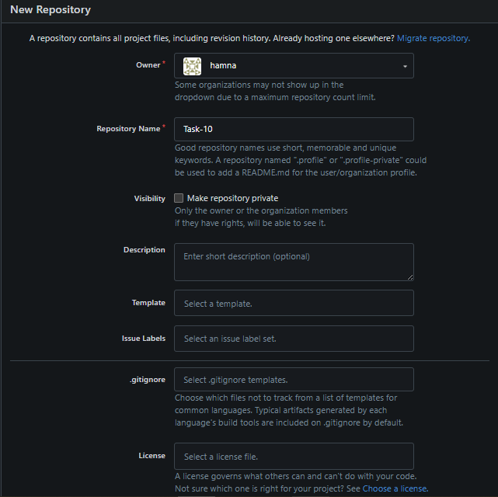

**Task 11**

**Creating a GitHub Pages Portfolio Site**

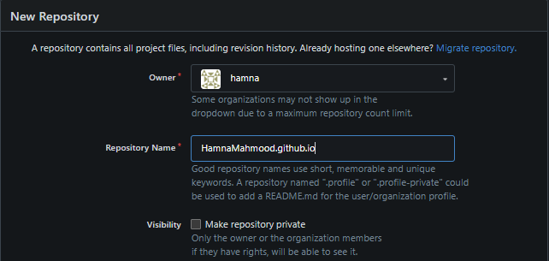

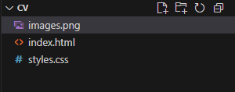

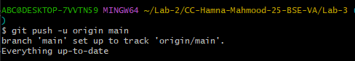

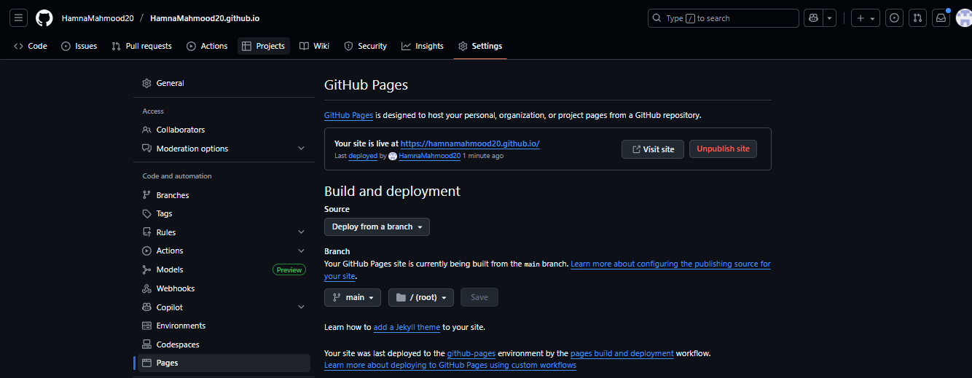



**Exam Evaluation Questions**

**1. Local vs Remote Conflict Resolution**

**Step 1: On GitHub, edit a file (e.g., README.md) and commit the change.  
Screenshot:**

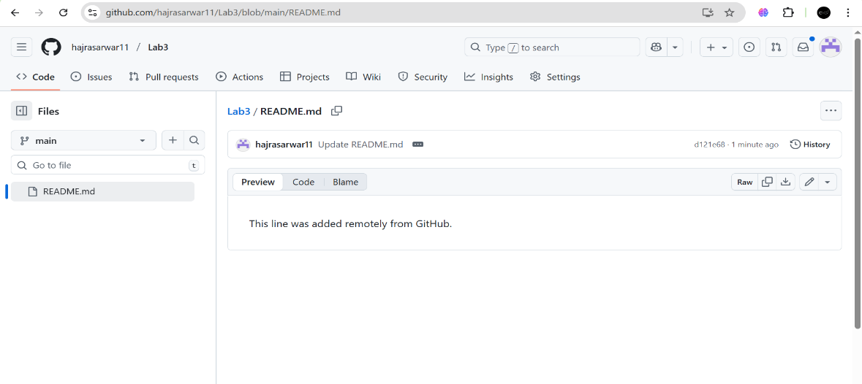

**Step 2: On your local machine, edit the same file differently (avoid conflict) and commit.  
Screenshot:**

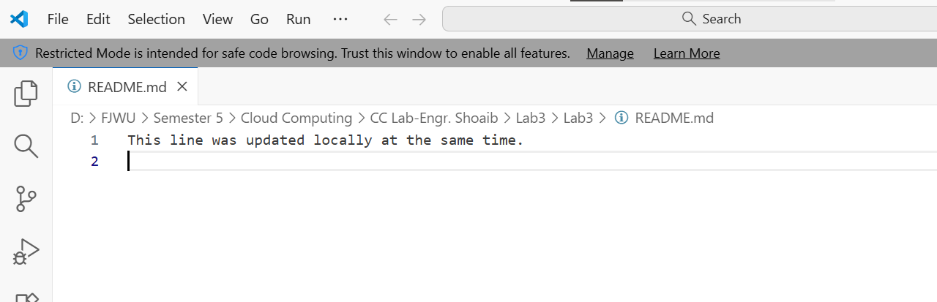

**Step 3: Try to push your local commit and observe the error.  
Screenshot:**

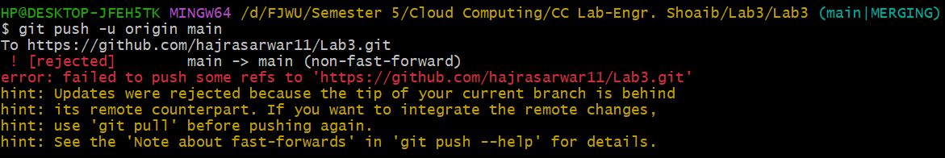

**Step 5: Repeat with another remote/local change, but resolve using git pull --rebase, then push.  
Screenshot:**

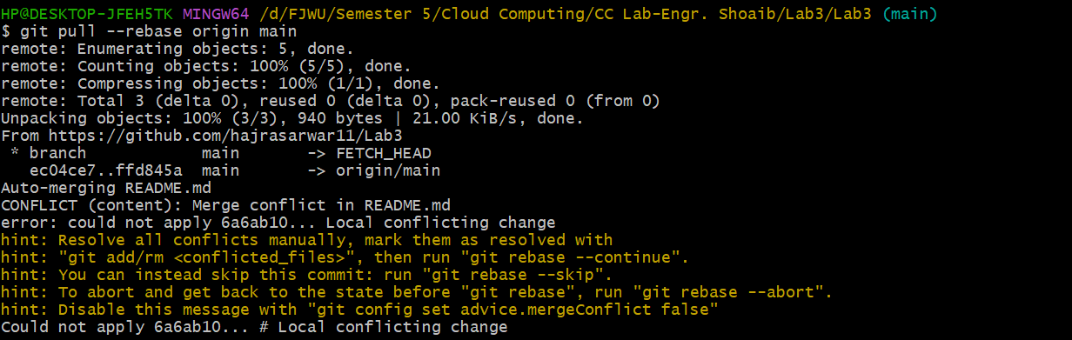

**2. Manual Merge Conflict Handling**

**Step 1: On GitHub, change a specific line in a file and commit.  
Screenshot:**

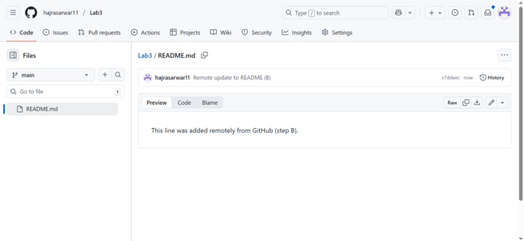

**Step 2: Locally, change the same line differently and commit.  
Screenshot:**

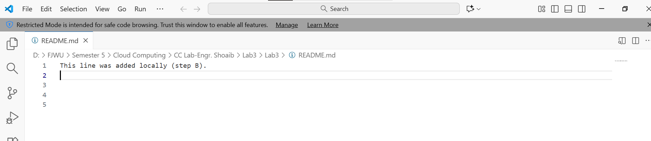

**Step 3: Try to push your local change and observe the conflict error.  
Screenshot:**

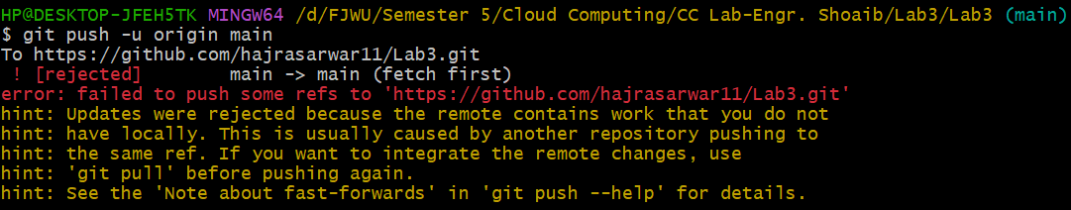

**Step 4: Use git pull --rebase to fetch changes and trigger the conflict.  
Screenshot:**



**Step 5: Edit the conflicted file to resolve the conflict manually.  
Screenshot:**

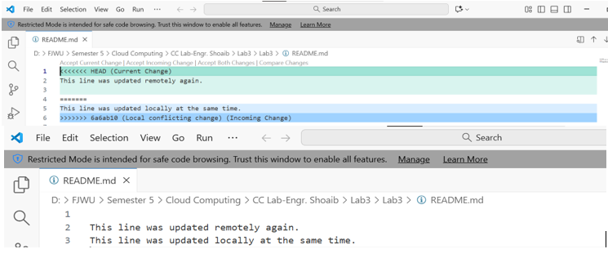

**Step 6: Mark the conflict resolved (git add <file>, git rebase --continue) and push.  
Screenshot:**

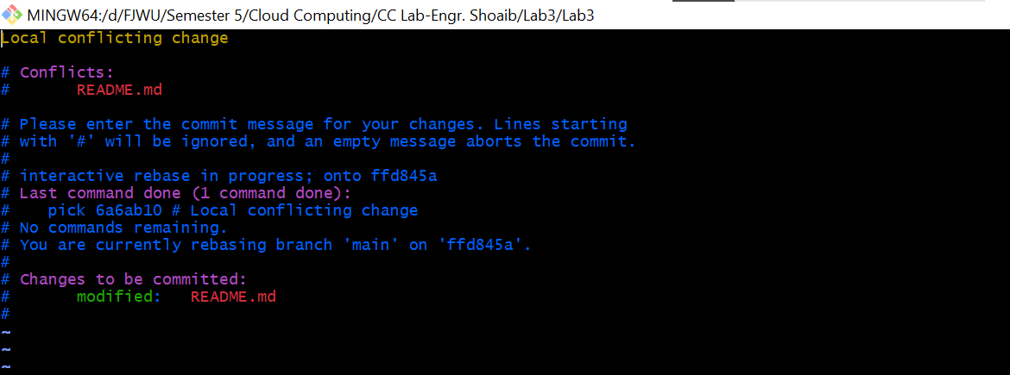

**3. Managing Ignored and Tracked Files**

**Step 1: Create a new folder (e.g., DocFiles) and add several files inside.  
Screenshot:**

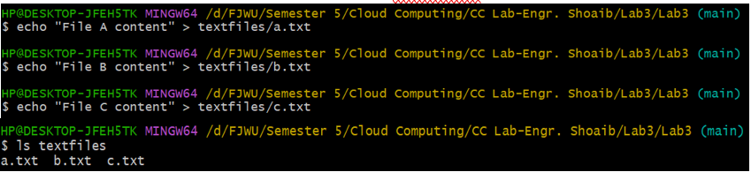

**Step 2: Commit and push the folder/files to GitHub.  
Screenshot:**

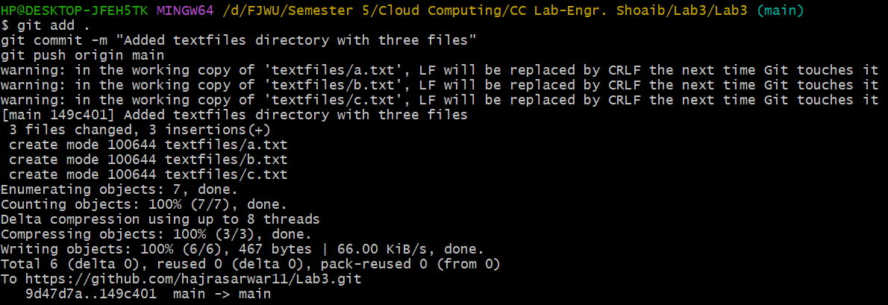

**Step 3: Add the folder to your .gitignore file.  
Screenshot:**



**Step 4: Commit and push the .gitignore update.  
Screenshot:**

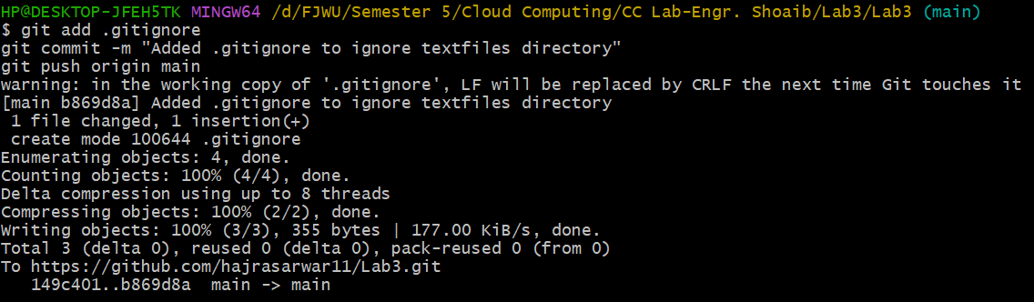

**Step 5: Remove the folder from tracking using git rm -r --cached <folder>.  
Screenshot:**

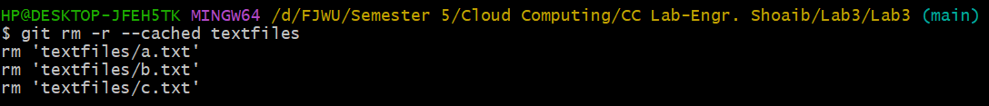

**Step 6: Commit and push the change, then verify the folder is no longer tracked on GitHub.  
Screenshot:**

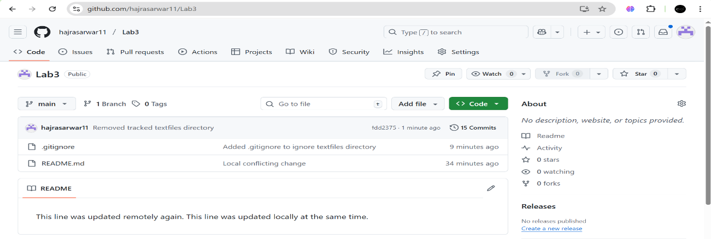

**4. Commit History Manipulation and Recovery**

**Step 1: Make a change and commit it.  
Screenshot:**

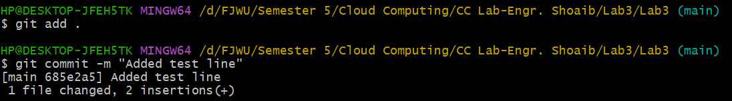

**Step 2: Make another change and commit again.  
Screenshot:**

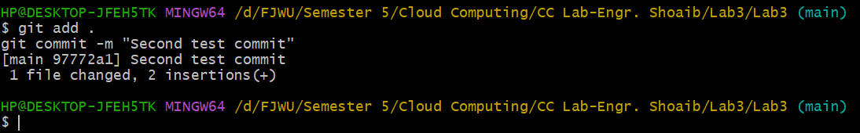

**Step 3: View your commit history.  
Screenshot:**

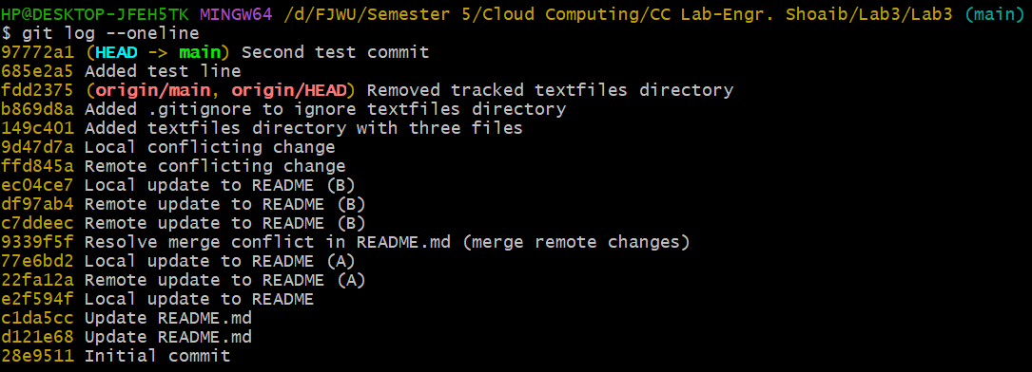

**Step 4: Perform a soft reset (git reset --soft HEAD~1) and observe your file and history.  
Screenshot:**

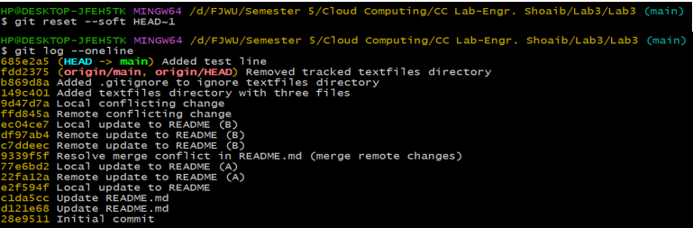

**Step 5: Make commit again.  
Screenshot:**



**Step 6: Perform a hard reset (git reset --hard HEAD~1) and observe the changes.  
Screenshot:**

